Research Exercise: Part I & II
Indiana University:
Instructional Systems Technology Distance Ed.D. Degree Program

by
Judith Slapak-Barski
EDD 7007 - Principles of Distance Education
Nova Southeastern University
Research Exercise: Part I
Part I: The institution and its programs

Identify a specific graduate degree program in instructional technology, distance education, or both, that is offered entirely or primarily via distance education. Identify just one program at one university. Answer the following questions:
1. List the name, mailing address, and website URL of the institution.

There are different mailing addresses, some of which are:
- Indiana University-Bloomington:
107 S. Indiana Ave.
Bloomington, IN 47405-7000
- IU Visitor Information Center
Carmichael Center, Suite 104
530 E. Kirkwood Avenue
Bloomington, IN 47408
- Main Website: http://www.indiana.edu
- Degree Programs Website: http://iuconnected.iu.edu/CertificateDegreePrograms.aspx

2. What degrees and majors are offered in the identified program? For instance, NSU offers an EdD in instructional technology and distance education. Florida State University offers an M.S. in instructional systems design.
Name of Graduate Program:
Doctoral Degree (Ed.D.): Instructional Systems Technology Distance Ed.D. Degree Program

3. For how long has the institution been offering the identified program at a distance?
The Instructional Systems Technology (IST) department at IU traces its history back to the 1920s, but the program was first established in the 1940s, and it was called “Department of Audio-Visual Instruction”, and has been part of the School of Education ever since. The program is regarded as among the world's top IST programs, with graduates serving in faculty and professional roles across the world.
Then, in August of 2011, the Indiana Commission for Higher Education approved a new doctor of education degree (Ed.D.) in Instructional Systems Technology (IST) from the Indiana University School of Education to be delivered entirely through distance education technology. The new program is the first IU doctorate offered completely online. (Source: http://newsinfo.iu.edu/news/page/normal/19372.html)
The motto of the Department of Instructional Systems Technology is to take a “holistic look at how to improve teaching and learning for all ages across all segments of society through the study and design of learning environments and strategies”. (Source: http://education.indiana.edu/about/departments/instructional/index.html).
In 2010 Indiana University established “IUconnectED”, which provides “coordination and support for all of the distance education courses and programs offered through the School of Education”. (Source: http://iuconnected.iu.edu/CertificateDegreePrograms.aspx)

4. What course delivery technologies are used? (Be specific: general terms such as “Webbased” are insufficient.)

Course delivery technologies used involve both Distance Education (Online) and face-to-face instruction:
IST Distance Instruction:
For students in the IST Distance program, the Hardware and Software requirements are as follows:
- All students must have the following computer and connectivity configuration, at a minimum:
Hardware:
- PC with Microsoft Windows XP, Vista, 7 or higher; or Mac with OS X (version 10.3 or higher)
- Memory: 2 GB or more recommended
- 1024 X 768 screen resolution or higher
- Speakers for sound or headphones1
- 60 GB Hard Drive (at least 20-40 GB free)
- Printer

Connectivity Requirements:
- Broadband Internet Connection
- DSL/Cable Modem
- Peripherals (access to the following is recommended):
- Speakers and microphone (must be a headset)
- Web-cam
- Scanner

Software via IUWare:
- Symantec Endpoint Protection
- Adobe Design Premium
- Adobe Production Premium
- Adobe Contribute
- Adobe Captivate
- Adobe Acrobat Pro
- Microsoft Office 2007, 2010 or higher
- Microsoft Windows Vista, 7 or higher; or Mac OS X Snow Leopard or higher

Free downloads and discount prices on hardware and software for IU students can be found at: http://iuware.indiana.edu
(Source: https://education.indiana.edu/graduate/programs/instructional-systems/hardware-software-requirement)

Face-to-face instruction:
Please see answer to question 5 below:
5. Is there a face-to-face component of instruction? If so, where is it conducted, and for what duration?

While all coursework hours are online, there is a face-to-face component to the program, although the face-to-face hours are not necessarily a part of specific courses. Students satisfy the face-to-face requirements by attending certain conferences and presentations, and taking qualifying exams and defending dissertations. These activities count towards the minimum requirement of three trips that students have to make to the IU Bloomington campus during their program of study. Online students: (1) must attend one of the annual IST conferences that feature presentations about pertinent topics by students, faculty, alumni and others in the field; (2) must take qualifying exams and conduct their dissertation defense on campus; and (3) are encouraged to attend meetings and conferences of professional organizations within the IST discipline, such as the Association for Educational Communications and Technology and the International Society for Performance Improvement. (Source: http://newsinfo.iu.edu/news/page/normal/19372.html)
6. How long does it take to earn a degree in the identified program? (Indicate either the briefest amount of time required or, preferably, the amount of time most students require.)

I was not able to find exactly how long it takes to get a degree in Instructional Systems Technology (IST) Doctor of Education (Ed.D.), or the amount of time most students require. What I di find s the summary of coursework and amount of credit hours needed, as detailed below:
The Instructional Systems Technology (IST) Doctor of Education (Ed.D.) degree program is a 60 credit-hour (minimum) post-master's graduate program. In order to begin the Ed.D. program, an individual must have completed a master's degree program from an accredited institution.
(Source: http://education.indiana.edu/graduate/programs/instructional-systems/)
Summary of Coursework
- IST Major (30 hours taken from IU)
- IST Inquiry Linkage (6 hours)
- IST Electives (24 hours)
- Non-IST (21 hours)
- Inquiry (9 hours)
- Learning Theories (3 hours)
- Minor (9-16* hours)
IST (9 hours taken from IU)
- Dissertation Proposal Preparation (3 hours)
- Dissertation (6 hours)
Total: 51 hrs. courses + 9 hrs. dissertation = 60 hrs.
A minimum of 42 credits of the 60 credits required for the Ed.D. must be taken from Indiana University (IU Bloomington or IUPUI) (Work completed towards a master's degree does not apply toward meeting the 60 credit-hour requirement, but post-master's degree work may apply, with decisions made on a case-by-case basis by the student's program advisory committee. A 90-credit post-bachelor's degree is also possible, where the first 36 credits are taken in IST to achieve a master’s degree, and the remaining 54 are taken for the Ed.D.)
Other requirements:
- Residency (attendance on the Bloomington campus during at least one IST Colloquium or IST Conference)
- Qualifying exam (proctored written exam on the Bloomington campus, and oral defense)
- Nomination to Candidacy (after completion of all course work - excluding dissertation - and after passing written and oral qualifying exams)
- Dissertation Research Committee Approval
- Dissertation Prospectus (after Nomination to Candidacy and with consultation and approval from Dissertation Research Committee) and Institutional Board Review (IRB) Approval for research involving human subjects
- Dissertation Proposal Defense:
  - Dissertation Final Defense Announcement (with approval from dissertation chairperson, and at least 30 days prior to final defense)
- Dissertation Final Defense
7. Is the institution accredited? If so, by what organization? [.5 point]

The Indiana University School of Education is accredited by two of the nation’s leading bodies for teacher education and higher education:
• National Council for Accreditation of Teacher Education (NCATE)
• North Central Commission on Institutions of Higher Education (NCCIHE)
The Indiana University School of Education is also a member of the American Association of Colleges for Teacher Education (AACTE).
(Source: http://education.indiana.edu/about/accreditation.html)
8. Is the institution public or private? If private, is it for-profit or not-for-profit?
The institution is a Public, land grant institution. (Source: http://www.iub.edu/about/index.shtml)
9. What is the total enrollment of the institution? How many students are enrolled in the identified distance-delivered program?
This fall, the institution enrolled a record 115,400 students across the state. Most of IU’s campuses also achieved record enrollment, including a record 46,817 students in Bloomington. And on nearly every measure of quality and achievement this is also a record class across the entire university.

(Source: http://vpcfo.iu.edu/doc/fy2013.pdf)

10. What is the tuition (per course or per year)? (For graduate programs)

Indiana residents:

Fee per credit hour: $373.00

Eligible out-of-state online learning students:

Fee per credit hour: $466.00

Out-of-state residents are eligible for the online rates (listed above) if they are admitted to an Indiana State University online program, and/or enroll only in online courses.

Out-of-state residents who do not meet these eligibility requirements will be charged out-of-state tuition.

Out-of-state and international residents:

Fee per credit hour: $733.00

In addition:

An online education delivery fee of $50 per graduate course will also be assessed to online learning courses. (Source: http://www.indstate.edu/tuition/fall2013-2014-graduate/index.htm)

Research Exercise: Part II

Part II: The institution’s website
Critique the institution’s (or program’s) website, answering the following questions:
A. How would you rate the visual appeal of the site? What elements are visually appealing, and which aspects are less so? Include screen shot(s) to illustrate.
I would rate the visual appeal of the site as “8” on a scale of 1-10, with 1 being poor and 10 being excellent.
The visually appealing elements included the slideshow on the home page, and the youtube link to the "Where can you take an IU degree?" video (shown below).
The aspects that I found less visually appealing is the excessive use of red (I found it a little bit “too much”, at least for my taste):
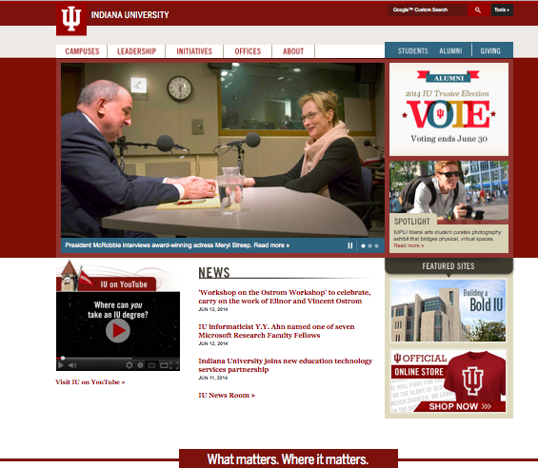

B. Is the site easily navigable and well organized? Provide examples.
No, the site is not too easy to navigate. One has to log out of the site and access other sites for information relevant to the Information Technology Systems program, as well as online degrees.
Also, on the main site/page, some links seemed redundant: as soon as the mouse is hovered on top of the main links, every one of those main links' sub-links lists exactly the same information as listed when going into these links (example below):
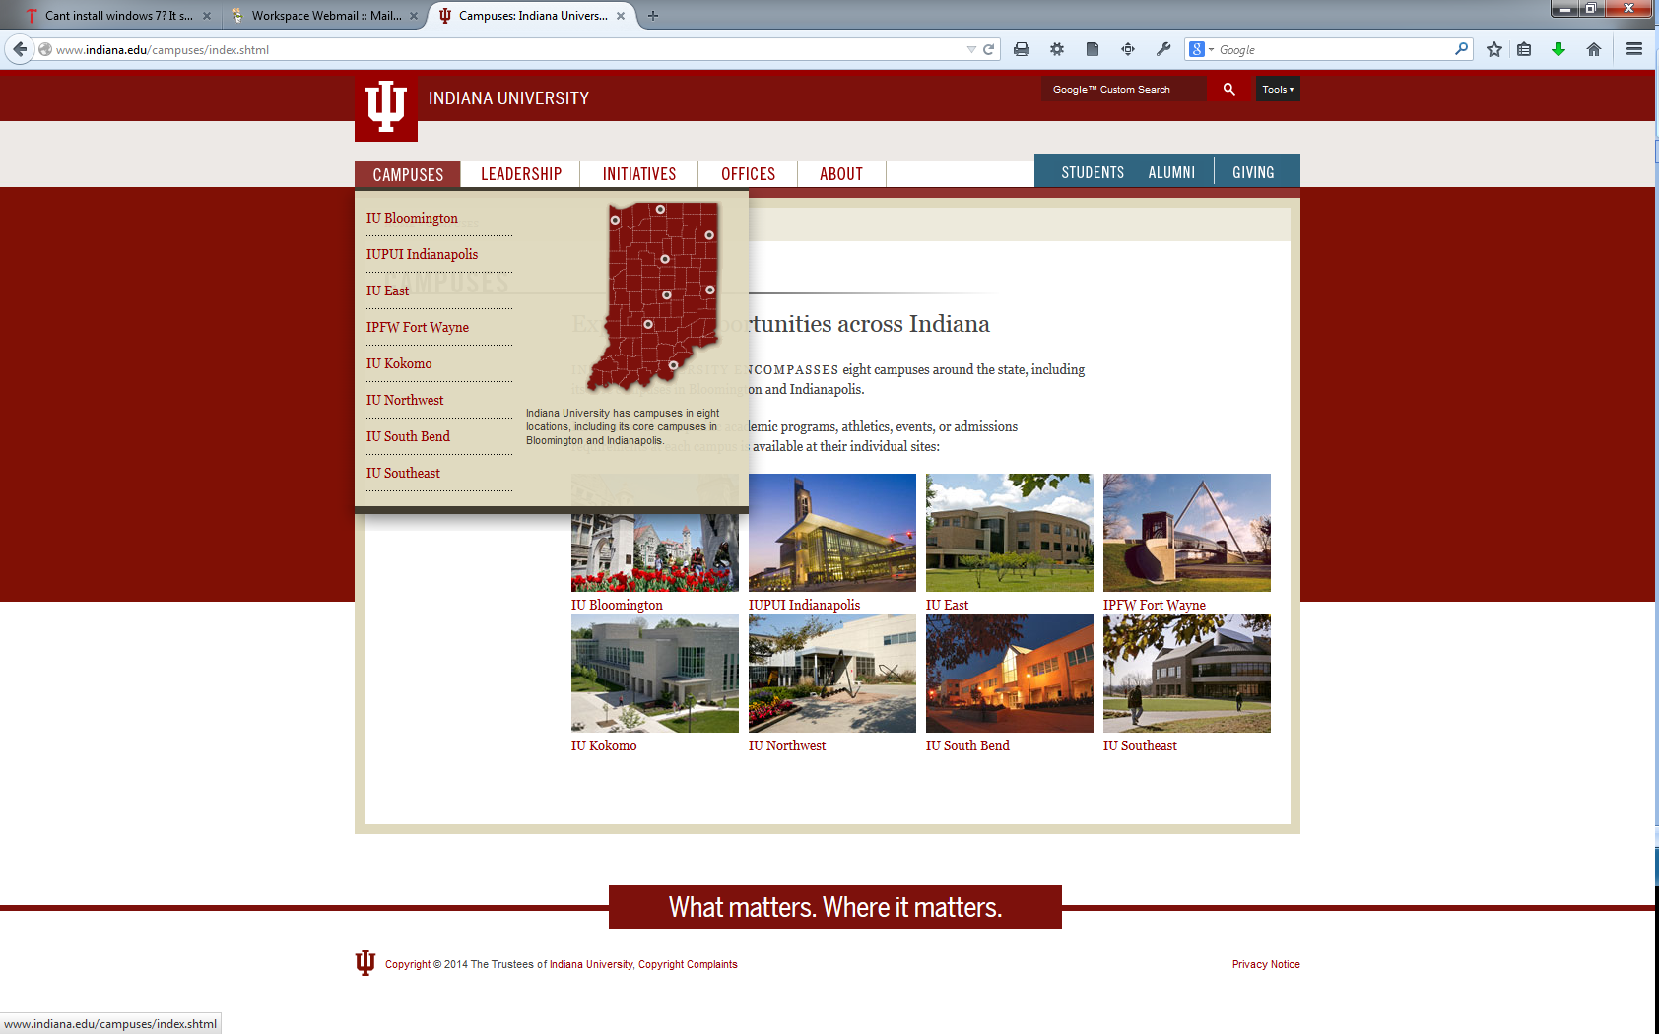

C. Does the site contain sufficient information to answer questions 1-10? If not, provide details.
No, the site does not contain sufficient information to answer questions 1-10. For example, there is no data on enrollment numbers for the Information Technology System programs.
The instructions below explain how to see how many students are enrolled for a course at Indiana University:
- Log into OneStart. The "Student Center" area should be visible; if it is not, select the Services tab, and choose the Student Self-Service section on the left.
Click Go to Student Center.
Note: If your Internet pop-up blocker is set to block all pop-ups, you'll need to turn it off or change the setting to allow them; refer to your browser help for instructions. For further assistance, contact your local Support Center.
- Click Search for Classes (either the link on the left or the button on the right).
- From the "Institution:" drop-down menu, select your campus. From the drop-down menu next to "Term:", select a semester.
- In the "Subject:" field, type a departmental code (e.g., eng or geog). Click select subject for a list of valid codes.
- Enter a full or partial course number, using the drop-down menu to change the type of match you are using. Uncheck Show Open Classes Only.
For more search options (e.g., section number, instructor's name), click the arrow next to "Additional Search Criteria", and enter your terms in the new fields.
- Click Search. The search results will display the number of seats still available in the "Avail" column for each course. In the "Wait" column, you can see how many students have waitlisted the course. If you click the Details button for a course, you can see the maximum enrollment possible for the course (next to "Class Capacity:")
D. What is the most positive aspect of the website?
The most positive aspect of the website is that it is fairly simple in appearance.
E. What aspect of the site is most in need of improvement?
The aspects of the site that need the most improvement are color scheme (too much red) and navigability to links that would provide additional information. Currently there are no links to relevant information, such as the number of students enrolled in the Information Technology Systems program. Also, the fact that the user needs to exit one site in order to visit another, present a problem. For example, the main site is located at indiana.edu, but the Information Technology site is at it.iu.edu. Also, I didn't find it easy to located degrees, courses, etc.

